External Documentation for the Team Project

Comp 229

Submitted to: -

Tom Tsiliopoulos

**IK**

Submitted by:

Iqbal Gill – 300878148

Khushdial Singh – 300878370

Table of content: -

1. Description of Web App.
2. Short version history.
3. Typography and Color Section
4. Wireframe Section
5. Screen Capture Section
6. Description of Web App

This ASP.NET web form application will track four games every week. The Main Game Tracking page (the HOME page) will provide stats of each game weekly and will update its contents according to the progress of the particular game. Each game is supposed to track two teams that will show the result of their particular match. All the data will be recorded in a database using all the required relations and tables.

Major factors of the web application are as follows:

* Main Game Tracking Page (HOME page)
* Teams page
* Login page
* Web Application Structure
* Hosting (Cloud Hosting)

1. Version History

This is the very first version of the web application.

Version 1.0

Github link: <https://github.com/KhushdialSingh/project.git>

Azure link: <http://ikricket.azurewebsites.net/>

1. Typography and Color Section

For this web forms application, ‘Verdana’ font has been used with the varying size and different colors in accordance with the particular web page.

1. Wireframe Section

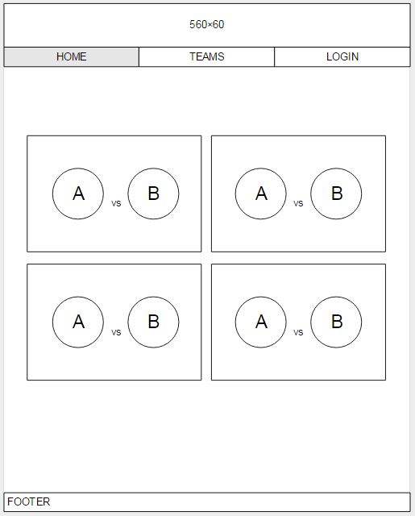

Home Page

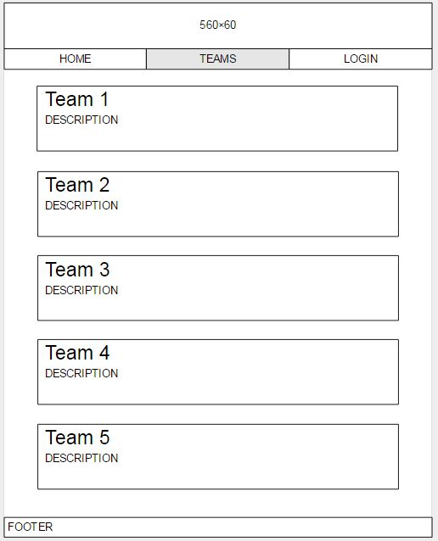

Teams Page

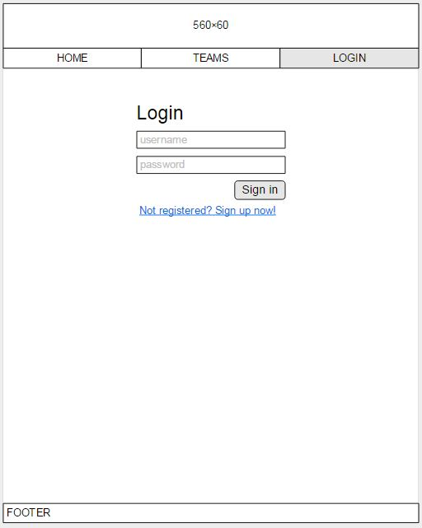

Login Page

1. Screen Capture Section